Why the software is being build?
building a Universal Document Management System (DMS) that can connect with any ERP system.
• A DMS = a system to store, manage, search, approve, and track documents
• An ERP = systems like SAP, Oracle, Dynamics that manage business processes
This system acts as a bridge between documents and ERP data
That’s a very important question — and I’m really glad you asked it.
If you understand why this system is being built, everything else (tech stack, React, Next.js, APIs) will make much more sense.
I’ll explain this clearly, practically, and in real-world terms.

🌍 The REAL problem (Why this system exists)

In most companies today:
- Documents are everywhere
  - Emails
  - Local PCs
  - Google Drive
  - WhatsApp
  - Paper files 😐
- ERP systems (SAP, Oracle, Dynamics) store data, but:
  - They are bad at handling documents
  - Documents are uploaded manually
  - No proper search
  - No smart approvals
  - Weak audit trails
👉 Result: Chaos, delays, mistakes, compliance risks

❌ What goes wrong WITHOUT this system
Let’s look at real problems companies face:

1️⃣ Manual document handling
- Someone downloads an invoice
- Uploads it to ERP manually
- Emails it for approval
- Forgets to follow up
⏳ Takes days instead of minutes

2️⃣ Documents are not linked to ERP data
- Invoice exists in email
- Purchase Order exists in ERP
- No automatic connection between them
❗ Causes:
- Wrong payments
- Duplicate invoices
- Audit failures

3️⃣ No proper audit trail
Auditors ask:
“Who approved this invoice?”
Company answers:
“Umm… let me check emails…”
🚨 Big compliance risk

4️⃣ Scaling becomes impossible
- Works with 100 documents
- Breaks with 1 million documents

✅ What THIS system solves
This system exists to fix all of that.

🔑 Core reason: Make documents part of business processes
Instead of:
“Documents are just files”
This system makes them:
“Active participants in ERP workflows”

🧠 What the system actually does (Simple)

1️⃣ Centralizes all documents
- One secure place
- Searchable
- Version-controlled
- Always available

2️⃣ Connects documents to ERP automatically
Example:
- ERP creates Purchase Order #123
- Invoice uploaded
- System auto-links invoice → PO #123
- Approval starts automatically
✅ No manual linking
✅ No mistakes

3️⃣ Automates workflows
- Upload → OCR → classification
- Approval → ERP update
- Notifications → reminders → escalations
⏱️ Saves 60–80% time

4️⃣ Ensures compliance & security
- Every action logged
- No document tampering
- Legal & audit-ready

5️⃣ Scales with the company
- 10 users → 10,000 users
- 1,000 docs → 100 million docs

🏢 Who benefits from this system?

📌 Finance teams
- Faster invoice processing
- No duplicate payments
- Clean audit trails

📌 HR teams
- Secure employee records
- Controlled access

📌 Management
- Clear visibility
- Reports & analytics

📌 Auditors
- One-click audit logs

📌 IT teams
- Secure, scalable platform
- Easy ERP integration

💰 Business impact (Why companies PAY for this)
Area | Impact
Time | 60–70% faster processing
Cost | Less manual labor
Risk | Fewer compliance issues
Accuracy | Fewer errors
Growth | Easy scaling
👉 That’s why this is an enterprise-grade product, not a small app.

🧩 Why YOU are building it (as a developer)
This project teaches you:
- Enterprise architecture
- Real ERP integration
- Secure systems
- Workflow automation
- Scalable frontend & backend
- Real-world problem solving
📌 This is industry-level experience, not just academic.

🧠 One sentence summary (Remember this)
We are building this system to eliminate document chaos by making documents intelligent, automated, and tightly integrated with ERP business processes.

4.2.1. Document management core
Document management core is the foundation to the whole document management system.
This engine stores, organizes, understands, versions, and retrieves documents.
Everything else depend on this core.
Core has 3 main parts as follow 3 topics.
1. Document Storage and Organization
a. Hierarchical folder structures with unlimited depth
Folders inside folders inside folders, as an example,
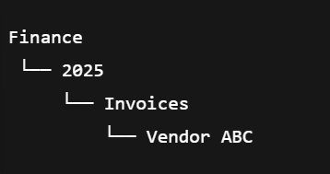
matches how company already think and easy to navigate for humans
Front end shows folders and backend stores folder relationships in db.
(how the backend stores folder relationships
The backend stores folders in a database table where each folder points to its parent folder. This is called tree structure.
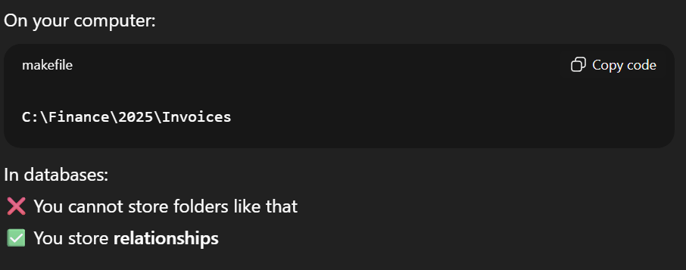
The best approach to achieve this is “Adjacency List Model”. We have to use this model in out project.
sample folder table in database(This is like a template folder table)
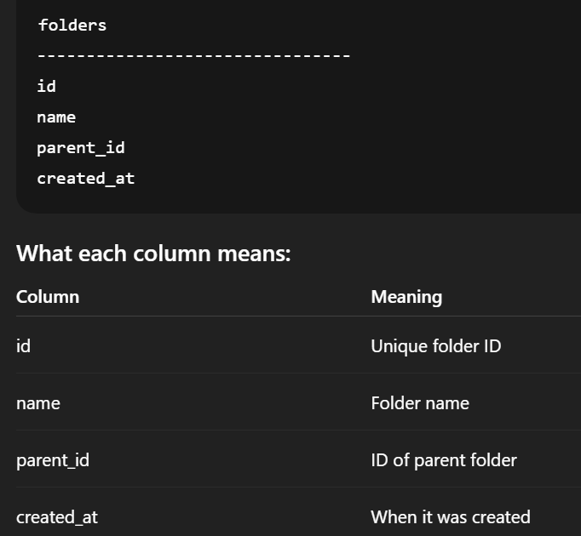
example for this template,
if we have a folder structure like this,
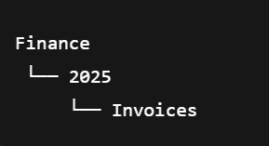
we have to store it in the database as follows,
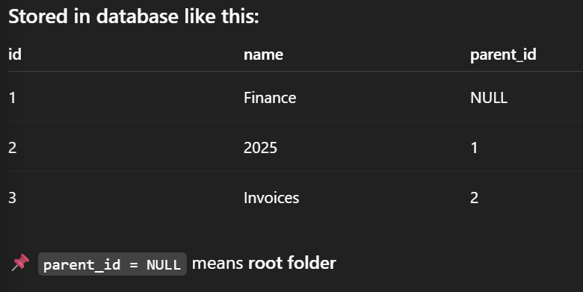
in here we have relationships for the same table. That is how the hierarchical structure is gained.
Now lets’ see how the backend understand this structure which we stored in the db,
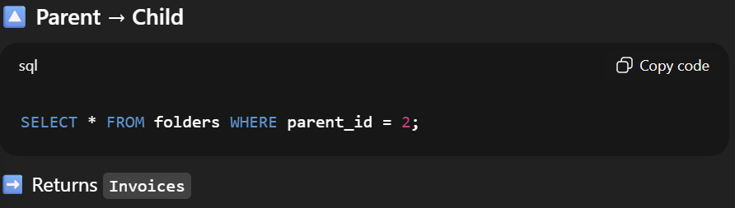
This will return Invoices because The sql command is to select all where the parent_id=2.
This is how the backend moves down the hierarchy.
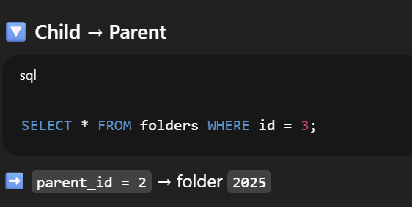
In here the sql command ask to return all which have id 3. This will return the 3rd column of the folders table and there we can identify the parent folder of that folder with that id.
This is how the backend moves up the hierarchy. Here we call the id instead of the parent_id.
when we call parent_id it selects the folder with the higher level and then we can see what the child class of that sing the row returns form the sql query and see the id column. So the backend can moves down the hierarchy.
when we call id, it selects the folder with the lower level and then we can see what is the parent folder using the row that returns from the sql query, seeing the parent_id column. So the backend moves up the hierarchy.
Documents are also linked by IDs. They do not live inside the folders physically.
There is a separate folder for documents as well.
Template for documents,
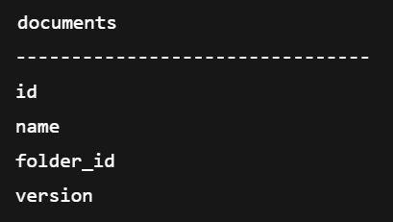
e.g:-
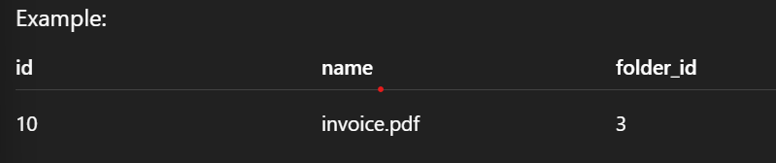
In here document is inside the invoice folder.
)
(What will happens when a folder is deleted?
By using backend rules we can,
prevent deletion if folder has children
mark as deleted
move documents to archive
)
Back end steps to build this hierarchical structure,
Fetch all the folders user can access
Group them by parent id
build a tree structure in memory
Send JSON to frontend
example API response:-
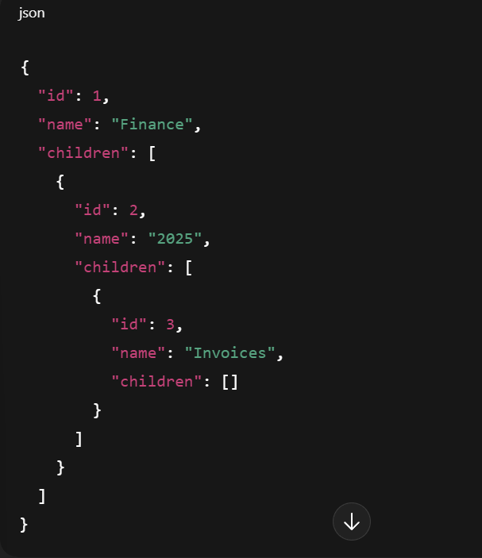
frontend render this.(render-process of converting code in to visuals)
In here every folder has access rules. There is a separate folder for the permissions,
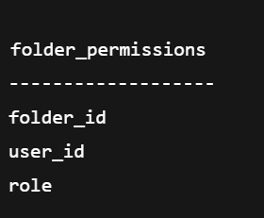
example template for the table for the permission table. The backend checks whether the user is eligible to see this folder or not.
we use this structure because storing full path is bad,
rename breaks everything.
Moving folder is expensive.
Hard to manage permissions.
b. Metadata-driven organization with custom fields
In here the documents are organized by their properties.
Metadata=data about the document
e.g.:-invoice number, vendor name, date, Amount, ERP ID
Searching with meta data is faster and smart that searching folders.
Searching is way more convenient with meta data.
e.g.:- Show invoices from Vendor ABC above 50 rupees.
How to achieve this in our project,
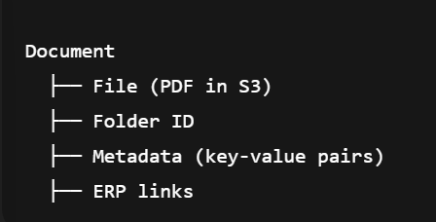
Backend design for metadata-driven organization,
Our project uses PostgreSQL + JSON
below is JSON metadata column
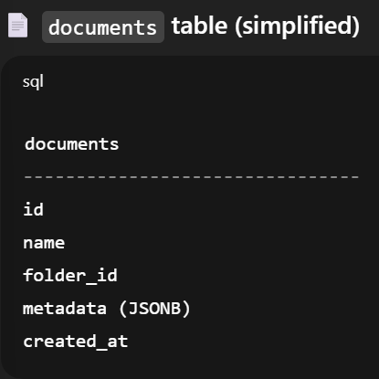
Example metadata store in JSON,
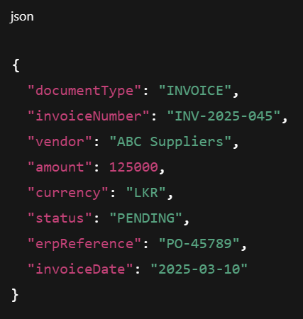
This is meta data driven organization
Example for metadata-driven search,
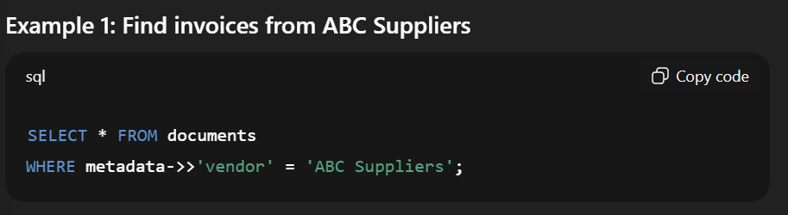
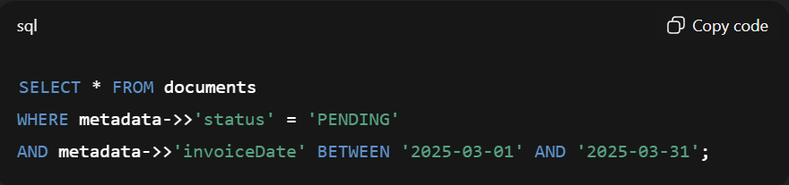
(This is my idea- we can use initially the main folders name and when the user selects that then the user can select form the fields that the system shows and then go step by step along the way. But this can only be used if the user knows exactly where the document is at or the system as to really specific about the appearance of the documents in the frontend.
Or we can use a search bar to search the document form the document pool. This search bar is available in all the folders that the user access and the user can search from the corresponding folders.
Or we can give fields to the user to enter and search the document once the user filled all the fields and submit.
Use filter and search boxes both one inside another
Filters are useful for dms manager to get a count within a certain time period and so on)
(How the flow works when finding a document
1.User type something

2.Frontend sends,
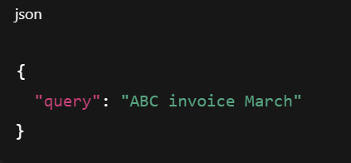
3.Backend search logic,
Backend does several things,
Step1:Query analysis,
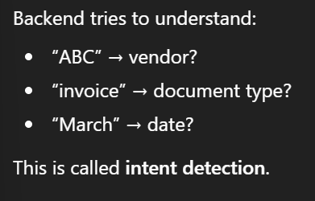
Step 2:Multi-field search,
Backend search multiple fields at once.
(File name, OCR text, Metadata values, Folder names)
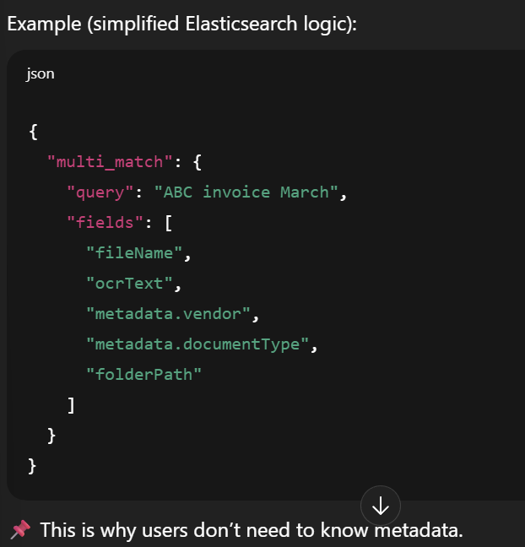
Step 3:Relevance scoring,
Elasticsearch scores results:
Exact matches->Higher score
Partial matches->lower score
Metadata matches->higher priority
4.Permission filtering
Even if a document matches,
backend checks,
“Does this user have permission to see this document”
If the user does not have permission to see that even the document is there it will be removed form the results.
5.Backend return final document list
Backend sends:
Document Id, Name, Snippet(Highlighted text), status, date
Still no file access yet.
6. Front end displays the results
User sees:
Matching documents, Highlighted search words, Filters (e.g. :- date, type)
When user clicks on a document,
Backend generates a secure s3 URL
File is fetched and then user can view and can also download the document.
Search never touches the s3 directly
)
(The backend searches INDEXES built from document data
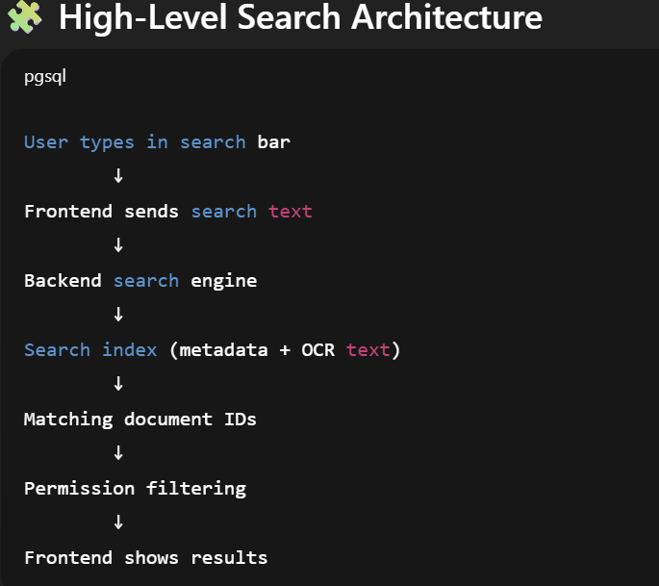
The backend does not,
Open PDFs in S3,
Scan files on every search,
Read documents again
What actually happens is,
Before searching ever works, the backend prepares the data.
Backend pipeline,
1.File stored in s3
2.OCR extracts text
3.Metadata is extracted/added
4.All this data is indexed
This happens once. Not in every search
[Search index-A fast, optimized structure made for searching]
Our system uses Elasticsearch
For each document the following is stored in each search index,
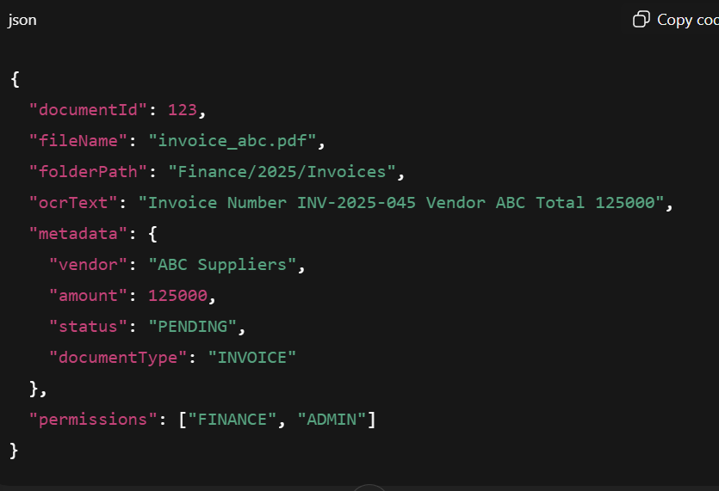
This is not stored in s3 but stored in Elasticsearch.
)
(When the user wants to upload the document user has to fill document metadata. After filling all the necessary metadata fields then only the user can upload the document.
User fills them -> frontend sends JSON -> backend stores it
The backend should be able to auto-fill metadata form
OCR
ML classification
ERP data
QR/Barcode
Example:-
• OCR reads invoice number
• ERP sends vendor ID
• Backend merges both
)
Metadata triggers automation( Metadata + workflow)
Examples:- if the amount>10000 it automatically triggers manager approval
if the vendor=new this automatically triggers finance review
If the status=expired the system must automatically sends an alert
ERP needs structured data. This can be achieved using metadata. Backend maps metadata to ERP fields.
Security,
Backend applies rules like using metadata
Examples,
Metadata + roles=access control
HR documents visible only to HR, Finance metadata hidden from others
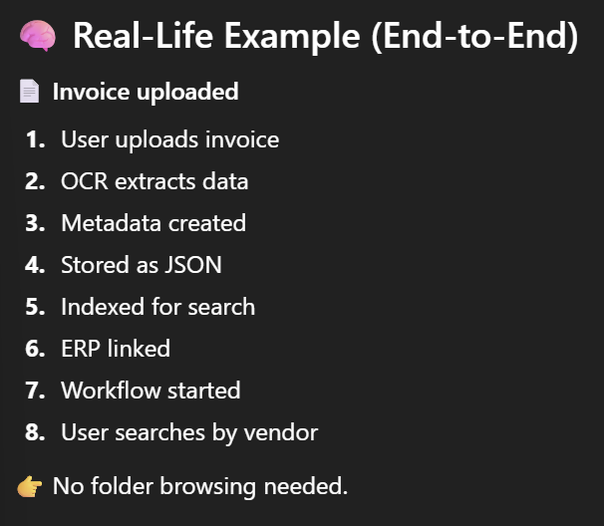
c. Version control with complete revision history
This means,
Every change creates a new version and the old versions are never lost.
Companies need this for,
Legal safety
Audit compliance
Mistake recover
Backend stores,
Version number
Who changed it
When the changes are made
What is changed
d. Document templates and standardized forms
The system has predefined document formats
e.g.:- Invoice templates, Contract templates, HR letter templates
e. Bulk import/export capabilities.
Upload or download many files at once

2. Document Capture & Processing
a. Multi-channel capture (email, scanner, mobile, API)
Documents can come from email, Scanners, mobile phones and API(ERP, other apps)

b. OCR with 99%+ accuracy for text extraction (OCR- Optical Character Recognition)
The OCR reads the text from images and PDFs.
This matters because Documents become more searchable and data can be extracted

automatically.
c. Intelligent document classification using ML
The system understands,
Is this an invoice or a contract or HR document? By using machine leaning model looks at content and assigns the document type automatically

d. Automated data extraction from structured documents
What data is extracted?
- Invoice number
- Date
- Amount
- Vendor name

Why this is critical:
- No manual typing
- ERP integration depends on this
Extracted data → stored as metadata → sent to ERP
e. Barcode and QR code recognition

Where used:
- Warehouse documents
- Logistics
- Manufacturing

Why:
- Fast identification
- Error-free linking
Example:
QR code → directly link document to ERP transaction

3.Search and Discovery
a. Full-text search across all document content
This means search inside document content not just file name
e.g.:- Search “Purchase order 3455”
OCR makes this possible
b. Advanced filtering by metadata, date, type, source
Filter by date, document type, metadata, source
e.g.:-Invoice from march 2025 over 10,000
c. Semantic(Smart) search with natural language queries
This means search by meaning, not exact words
e.g.:-pending supplier invoices
System understands:
Document type, status and vendor
d. Saved searches and alerts
This means save search conditions and get notified when new matches appear.
e.g.:-Notify me when new invoices arrive
Simply-“Remember my search conditions and run them again automatically.”
e. Document recommendation engine
This suggests related documents.
e.g.:- Viewing invoices->System suggests, related PO, Delivery notes, contract
How backend and frontend splits this document management core,
Frontend:
- Shows folders
- Upload UI
- Search UI
- Filters
- Versions display

Backend:
- Stores files
- Runs OCR & ML
- Maintains versions
- Extracts metadata
- Indexes documents
- Applies permissions

Simple real-life flow,
1️.User uploads PDF
2️. Stored in S3
3️.OCR extracts text
4️.ML classifies as “Invoice”
5️.Metadata extracted
6️.Linked to ERP PO
7️.Indexed for search
8️.Approval workflow starts
4.2.2.ERP integration engine
What is the ERP integration engine?
It is the brain that connects the Document Management System (DMS) with ERP systems like SAP, Oracle, Dynamics, etc.
Without this engine:
Documents are just files, ERP data and document
ERP data and documents are disconnected
With this engine:
Documents move together with business transactions
In companies:
- ERP controls money, inventory, HR
- Documents prove what happened
Auditors, finance teams, and managers need:
“Show me the document related to this ERP transaction.”

This engine makes that possible automatically.
4.Universal connector framework
This is how the one DMS can talk to many ERP systems.
a. Pre-built connectors for major ERPs (SAP, Oracle, Dynamics, etc.)
What this means:
- Ready-made connectors for:
  - SAP
  - Oracle
  - Microsoft Dynamics
  - Infor
  - Epicor
These connectors know:
- ERP APIs
- Authentication methods
- Data formats

This saves moths of work.
b. RESTful API for custom ERP integrations
Not all companies use big ERPs.
So the system provides:
- REST APIs
- Standard request/response formats

Any ERP with REST/SOAP can integrate.
c. Real-time bidirectional data synchronization
Bidirectional = both ways
- ERP → DMS
- DMS → ERP

Example:
- ERP creates Purchase Order → DMS notified
- Document approved in DMS → ERP updated
Keeps both systems in sync.
d. Event-driven integration with webhooks
What is a webhook?
ERP sends a message when something happens.
e.g.:-Invoice created.
DMS receives event → starts document workflow.
This is faster than polling.
e. Batch processing for large data volumes
Used when:
- Large data volumes
- Nightly sync
- Legacy systems
Example:
- Sync 100,000 old invoices at midnight

5. Business Process Integration
This is where documents become part of ERP workflow.
a. Automatic document-transaction linking
This means the documents are automatically linked to ERP records.
Example:
- Invoice → Purchase Order
- Contract → Vendor
- Certificate → Product

b. ERP-triggered document workflows
ERP events trigger workflows.
Example:
- ERP creates PO
- DMS waits for invoice
- Invoice uploaded
- Approval workflow starts
The ERP controls the flow, DMS handles documents.
c. Master data synchronization (customers, vendors, products)
Master data=reference data
Examples:
- Customers
- Vendors
- Products
Why needed:
- Metadata consistency
- Correct linking
- Accurate search
Synced regularly from ERP.
d. Financial document processing (invoices, POs, contracts)
This is the most common use case.
Handled documents:
- Invoices
- Purchase Orders
- Receipts
- Contracts
Includes:
- Invoice matching
- Approval routing
- ERP updates
e. Supply chain document management
Documents related to:
- Delivery notes
- Quality certificates
- Shipping documents
Linked to:
- Orders
- Inventory
- Suppliers
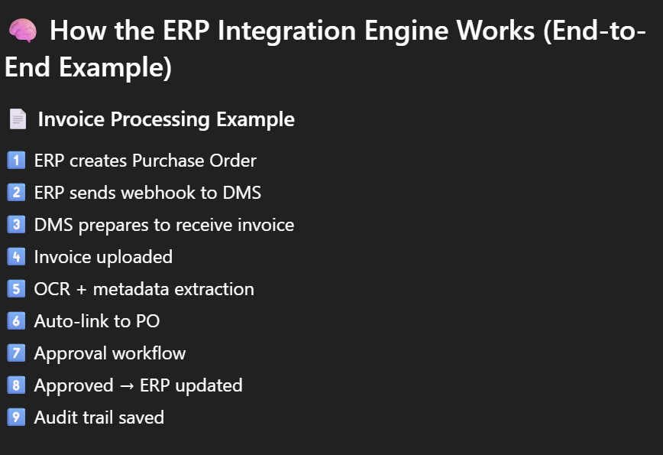
Backend and frontend responsibilities
Backend:
- Handles ERP authentication
- Maps ERP fields → metadata
- Handles retries & failures
- Logs integration events
- Maintains consistency
Frontend:
- Shows ERP status
- Displays linked transactions
- Shows errors (read-only)
Error Handling,
ERP systems:
- Go down
- Respond slowly
- Reject requests
So the engine includes:
- Retry logic
- Message queues (Kafka)
- Dead-letter queues
- Manual recovery

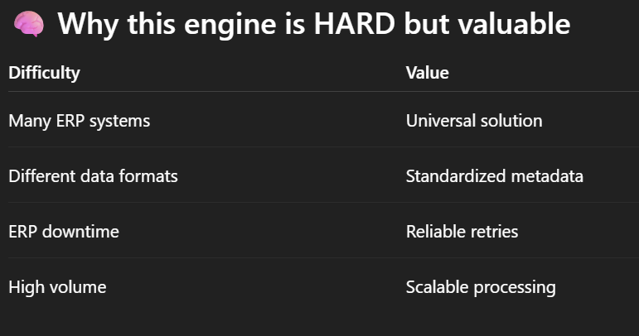
Key workflows,
8.2.ERP integration sync
This is how the system keep ERP data and documents in sync reliably and automatically.
ERP Integration Sync is the step-by-step backend process that reacts to ERP events, links documents, updates systems, and guarantees consistency and auditability.
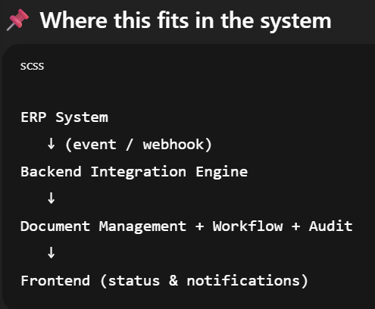
1. ERP event detected → Webhook received → Queue processing
What this means:
- Something happens in ERP (PO created, invoice approved, etc.)
- ERP sends a webhook to the backend
- Backend puts the event into a queue

Why a queue?
- ERP might send many events
- Backend processes them safely, one by one
- Prevents system overload

2. Data validation → Field mapping → Transform data
What happens here:
Backend checks:
- Is the event valid?
- Are required fields present?
Then:
- Maps ERP fields → internal fields
- Converts formats if needed
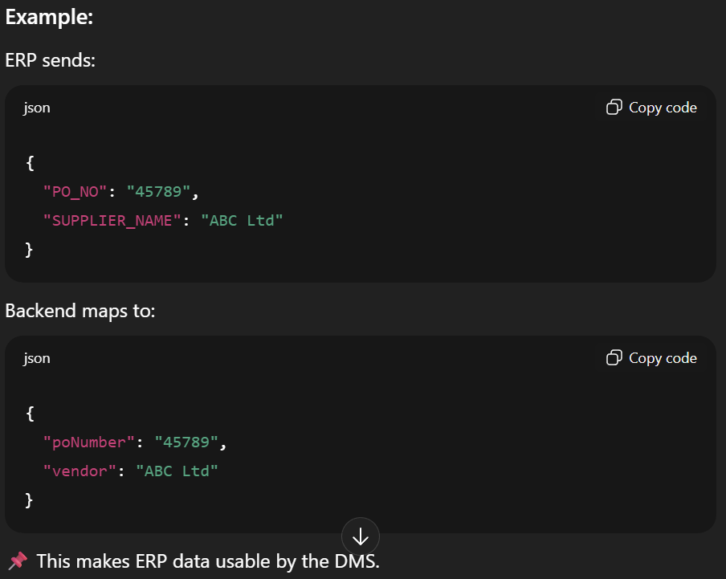

3. Document lookup → Create/update links → Trigger workflows
What the backend checks:
- Does a document already exist for this ERP transaction?
- If yes → link it
- If no → wait for document or create placeholder

Then:
- Start relevant workflow

Example:
- PO exists
- Invoice uploaded later
- Backend links invoice → PO
- Approval workflow starts

4. Sync status update → Error handling → Audit logging
Backend now:
- Marks sync as SUCCESS or FAILED
- If failed → logs error
- If needed → retries automatically

Audit logging:
- Who triggered it
- When it happened
- What changed
Auditors rely on this.

5. Notification sent → Dashboard update → Report generation
What users see:
- Notification: “Invoice linked to PO”
- Dashboard updates
- Reports reflect new data
Backend does not immediately update ERP in the same request, backend uses asynchronous processing.
because the ERP systems are slow, ERP can fail or Documents takes time to process.
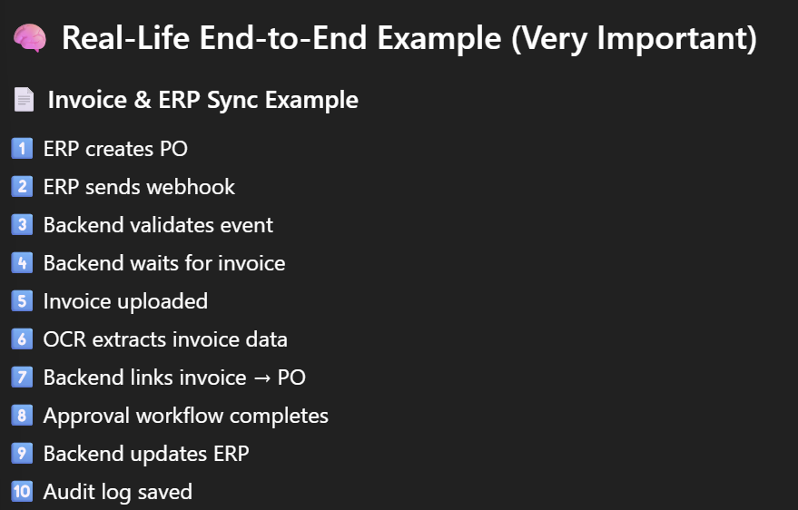
Security In ERP integration sync,
backend ensures:
ERP credentials are secure, No ERP logic exposed to frontend and Only authorized updates occur.
Frontend never talks to ERP or Knows ERP credentials.
(What if ERP is down?
Backend:
- Retries with exponential backoff
- Moves event to dead-letter queue
- Allows manual reprocessing
This prevents data loss.
)
9.1.Buil-in security
• Zero Trust Architecture: All requests authenticated/authorized
• Encryption Everywhere: Data encrypted at rest and in transit
• Role-Based Access: Granular permissions with least privilege
• Audit Everything: Immutable audit logs for all actions
• Multi-Factor Auth: Required for admin and sensitive operations
• Session Management: Secure sessions with automatic timeout
• Input Validation: Strict validation on all inputs
This explains how the system protects documents, users, and ERP data using authentication, authorization, and audit controls.
This is about who can access what, when, and how safely.
In an enterprise DMS:
- Documents include financial, legal, HR data
- ERP data is extremely sensitive
- A single leak = legal + financial damage
So security is not optional, it is core architecture.

This covers,
1.Authentication-who are you?
What this means:
The system must prove the user’s identity.

Common methods used:
- Username + password
- Single Sign-On (SSO)
- OAuth / SAML (enterprise standard)
- ERP identity federation

Example:
- User logs into DMS
- Same credentials work for ERP (SSO)
Backend validates identity->Issues secure token(JWT)
2️.Authorization (Role-based access)->what are you allowed to?
This is Role-Based Access Control (RBAC).

Roles example:
- Admin
- Finance Officer
- HR Manager
- Auditor
- Viewer
Each role defines:
- View documents
- Upload documents
- Approve workflows
- Access ERP-linked data
Authorization is checked on every request.
3️.Document-level security-even stronger protection
Not all users with same role can see same documents.

Controls include:
- Folder-level permissions
- Document-level permissions
- Metadata-based access rules

Example:
- Finance role
- Can only see invoices for their department
Permissions can depend on:
- User role
- Department
- Document metadata
- ERP ownership
4️.ERP security integration-No weak links
ERP systems:
- Have their own security
- Cannot trust frontend calls
So the system ensures:
- ERP credentials stored securely
- Backend-only ERP communication
- Token-based authentication
- Encrypted communication (TLS)

Frontend:
Never talks directly to ERP, always goes through backend.
5️.Audit & compliance
Every sensitive action is logged.
Logged events:
- Login / logout
- Document upload
- View / download
- Edit / delete
- ERP sync actions
- Approval decision

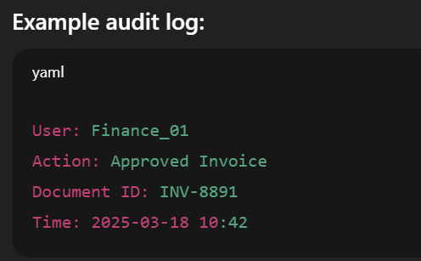
Required for:
ISO compliance, legal audits, internal investigations.
Advanced security methods mentioned in here are,
Encryption
- At rest (database, S3)
- In transit (HTTPS)

Version control
- Prevents unauthorized overwrites
- Keeps history

Least privilege principle
- Users get minimum access needed

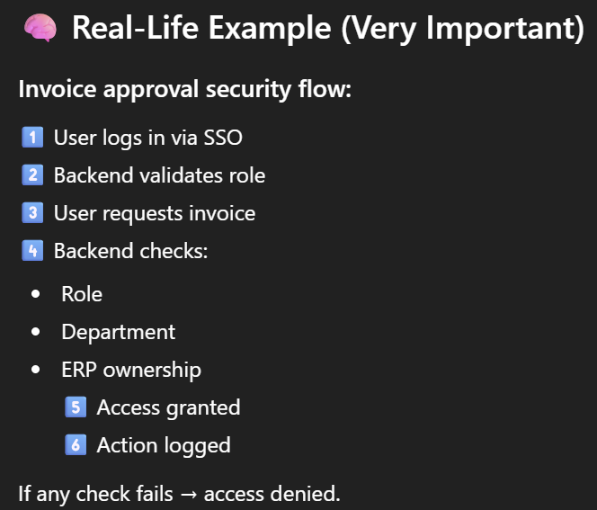
(What happens if security is weak?
- Unauthorized access
- Data leaks
- Compliance failure
- ERP corruption
)
10)Acceptance criteria
10.2.ERP integration
✓ At least 5 major ERP systems have working connectors
✓ Real-time sync maintains data consistency between DMS and ERP
✓ Document-transaction linking works for all supported document types
✓ Batch processing handles large data volumes without system impact
✓ Integration errors are logged and recoverable
✓ Custom field mapping supports any ERP schema
This is about deployment, scalability and high availability
This explains how the DMS + ERP Integration system is deployed, scaled, and kept running without downtime.
Enterprise systems must:
- Handle thousands of users
- Process millions of documents
- Never go down (or very rarely)
- Scale when load increases
This section answers:
“How does this system survive real-world usage?”

Main areas in the ERP Integration,
1.Deployment architecture
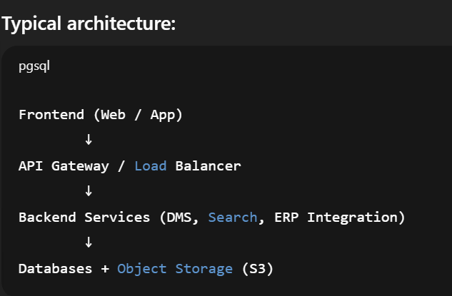
Each part is independent and replaceable.
This avoid single point of failure.
2️.Containerization & orchestration
What this means:
- Backend services run in containers (Docker)
- Containers are managed by Kubernetes

Why containers?
- Easy deployment
- Same behavior everywhere
- Quick scaling

Kubernetes handles:
- Service restarts
- Load balancing
- Rolling updates
- Auto-healing

If one container crashes it replaced
3️.Horizontal & vertical scaling
🔹 Horizontal scaling (most important)
- Add more service instances
- Load balancer distributes traffic

🔹 Vertical scaling
- Add more CPU/RAM to servers

Horizontal scaling is preferred for the system.
4️.High availability & failover
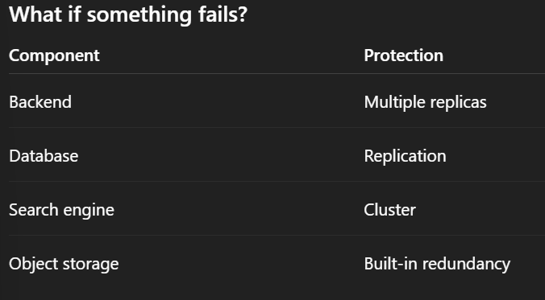
5️.Data durability & backups
Documents:
- Stored in S3 / object storage
- Multi-zone replication

Metadata & logs:
- Database backups
- Point-in-time recovery
This protects against:
- Hardware failure
- Accidental deletion
- Disaster recovery

6️.Monitoring & health checks
Monitoring tools track:
- CPU, memory
- Request latency
- Error rates
- Queue backlogs

Alerts trigger when:
- ERP sync fails
- Search index lags
- Storage is full
Ops team is notified immediately.
